Pouria Ghadimi
CSS430
Professor Dimpsey

Program 3: Synchronization

Report
Part 1’s Algorithm and design:
Parts inside the kernel were written following the instructions in the comments. First TCB was acquired then tid and pid based on the case and then enqueAndSleep and DequeAndWakeup were called.
SyncQueue class include four functions two constructors, enqueueAndSleep , and dequeueAndWakeup. In enqueueAndSleep the incoming thread is put to sleep and its tid will be returned for other threads to finish. In dequeueAndWakeup threads with the incoming pid will wakeup.
QueueNode file includes a Vector called queues. In sleep function first check is for it’s the parent by checking the size of the queue then this thread will be put into wait. In wakeup function incoming thread will be put to the vectors and next thread will be notified.

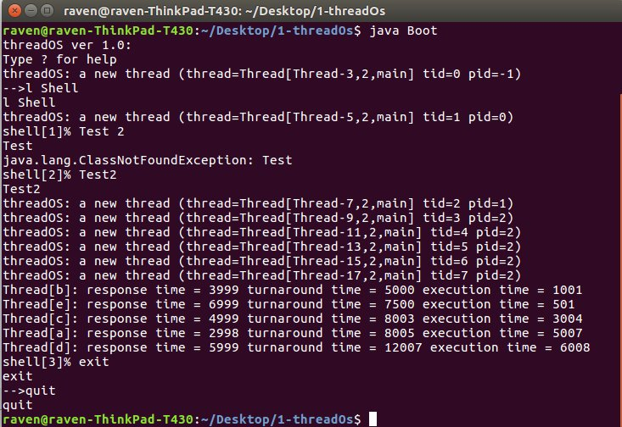
The overall result of the first part is fast and results are shown in the figure below:

Part 2’s Algorithm and design:

Parts inside the kernel were written following the instructions in the comments again. In each case has a while loop with conditions that inside each while ioQueue will call enqueueAndSleep.
In order to test this algorithm I created Test3 alongside TestThread3. In Test3 two arguments will be called for TestThread3. One will be TestThread3 A and the other one TestThread3 B. Then threads will be executed equal to the argument that will be written in front of Test3.
Inside TestThread3 if the calling thread is A it will calculate some random math equation. If it is B it will write some random bytes into a byte buffer for 1000 blocks.
Following is the results for Test3 in part 1 algorithm implementation:
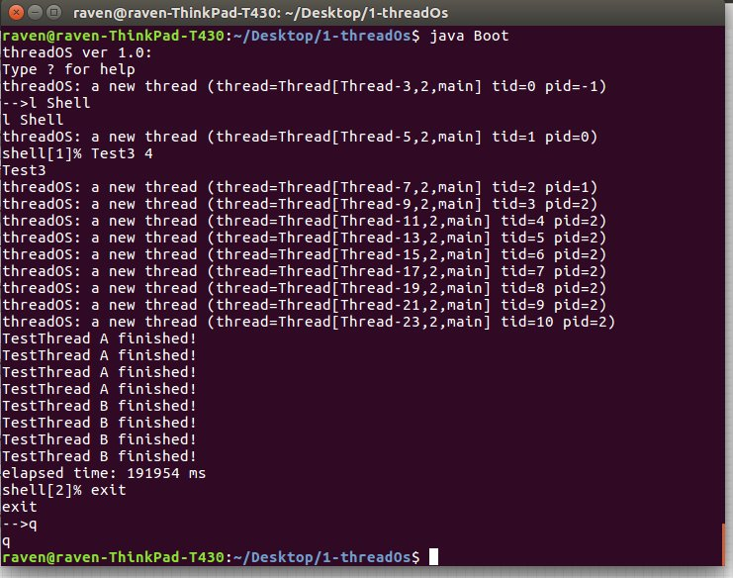
and next photo is the results for Test3 in part 2’s algorithm implementation:
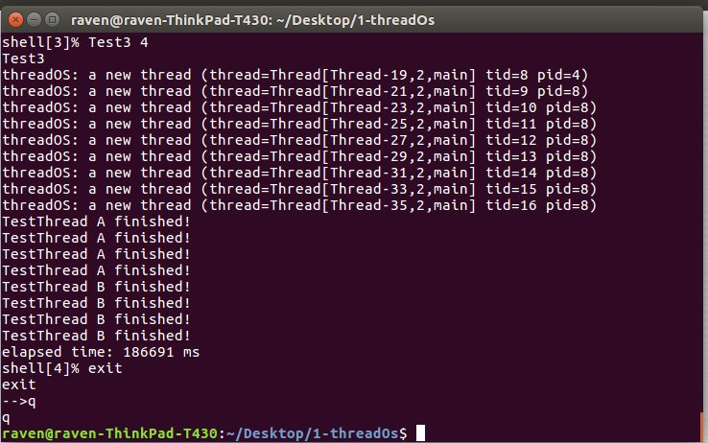
As it is visible in both figures second implementation will complete the task faster than the Firs part. Doing second algorithm helps the thread to wait less while they are reading compare to the first algorithm that happens one by one for each thread.

